**Responding to Art Activity**

**“The Good, the Bad and the Ugly” by Deanne Kasokeo**

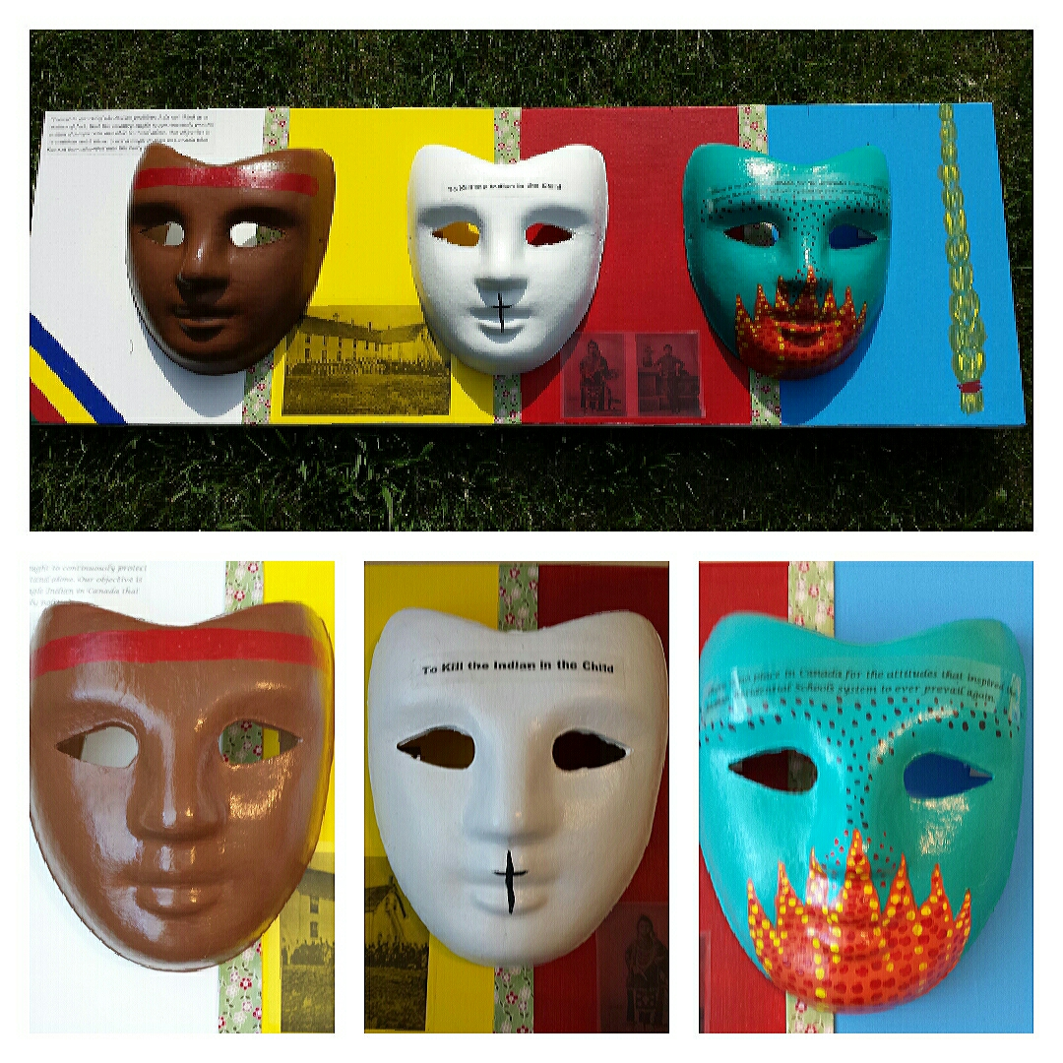 *Sculpture made with 3 masks mounted on painted canvas with collaged text and photos*

**What do you see?**

You can do this activity with a partner or as a whole class:

1. As you look carefully at the piece, describe what you see. List all the colours, the shapes, the materials used, and images.
2. Artists make very deliberate choices when they make art. What do you think the colours of the masks mean? What might the four colours of the background mean? Do they remind you of anything?
3. Discuss possible meanings for the symbols of the four stripes on the left lower corner, the red line on the mask on the left, the cross on the mouth of the middle mask and the drops and flames on the mask on the right.
4. What might be the significance of the braid of sweet grass on the right side?
5. Read the text aloud. (The full text is attached.) What questions do you have about them? What might you say in response? The photos collaged onto the bottom can be viewed more clearly on the attached page. What does residential school have to do with this art piece? What connection is the artist making?
6. Why do you think the artist chose the title “The Good, the Bad and the Ugly”?
7. What questions would you like to ask the artist?

**Artist video: go to ___________(link) ________________ to hear Deanne Kasokeo talk about her painting.**

**Text from “The Good, the Bad and the Ugly”:**

*Left upper corner:*

I want to get rid of the Indian problem … That has been the objective of Indian education and advancement since the earliest times … Our objective is to continue until there is not a single Indian in Canada that has not been absorbed into the body politic …

*Duncan Campbell Scott, Deputy Minister of Indian Affairs, 1920*

*Middle mask:*

To kill the Indian in the child.

*Right mask:*

There is no place in Canada for the attitudes that inspired the Indian residential schools system to ever again prevail.

*-From the Letter of Apology from the Harper Government, 2008*

**Photos on the art piece:**

This is a famous image of Thomas More – before going to residential school (left) and after residential school (right)

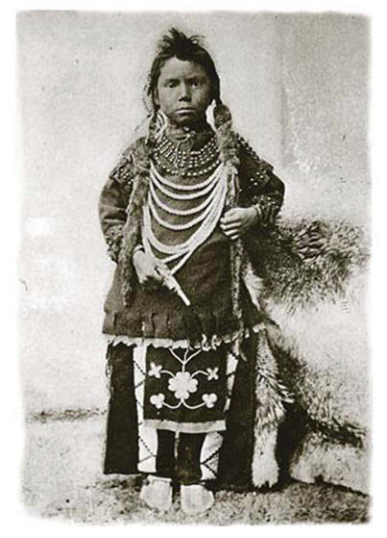 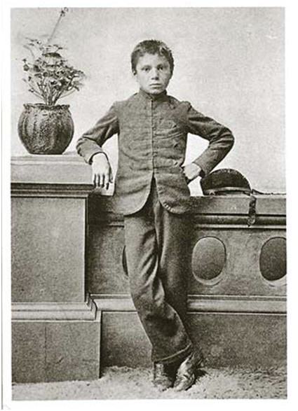

*Images from Saskatchewan Archives*

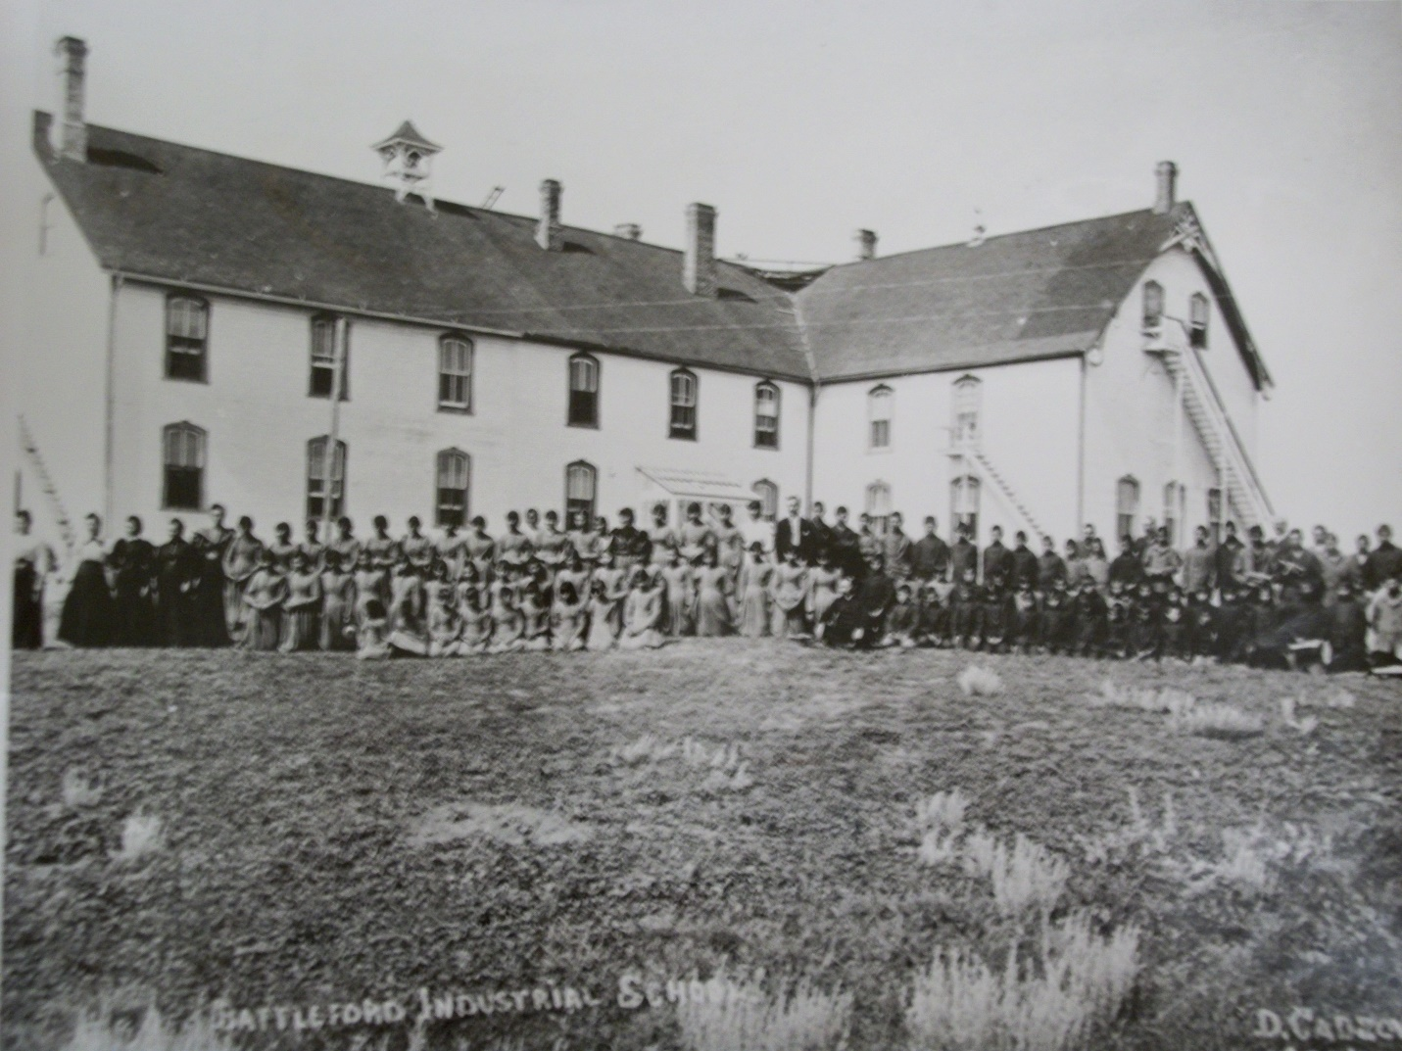

Battleford’s Industrial School for First Nation children. This was created in what was previously known as Government House. It has since been burned down and there is a monument on the site.

*Image from Saskatchewan Archives*

Your Turn to Make Art!

**Shared History to Shared Hope**

Postcards from the Heart –what are your thoughts about the impact residential schools had on family? What message would you like to give about the importance of healing? We have lots to be hopeful about – what are you hopeful for?

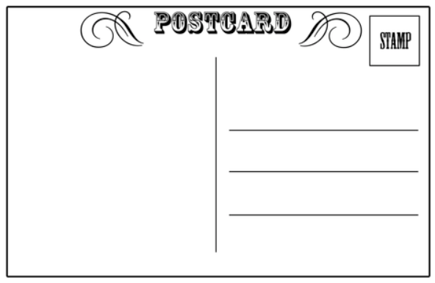Design and decorate the front of your postcard however you like. You can use any materials and can add text and photos if you like. This is called collage. On the back you can add writing.

Wouldn’t it be cool to trade your card with someone from another school?

Name

School

Grade

A personal message

A poem

A letter

A dream…

What do you wish to write?